



Name : Hafsa Shahid
Reg no : B25F34CYS101
Program : Cybersecurity
Instructor’s name: Hassan Ali
Date Submitted : 08 / 07 / 26
Deadline : 09 / 07 / 26
Assignment Report # 3

\

• INTRODUCTION •
In this class we learned Networking Fundamentals, IP Addressing, public and private IPs, NAT, Ports and Protocols, DNS and DHCP , and the differences between TCP and UDP. We were given an assignment at the end; it goes as follows.

Assignments Tasks:

Task # 01 : IP Address, Find IP address.

Task # 02 : Gateway, Find Gateway.

Task # 03 : DNS Server, Find DNS Server.

Task # 04 : Active Interfaces, Find and List Active Interfaces.

Task # 05 : Listening Ports, Find and List Listening Ports.

• TASK # 01 •
Task # 01 : IP Address, Find IP address.
Steps Followed:
- Open Kali Linux, then open terminal by using shortcut Ctrl + Alt + t.
- Type “ip a” or “hostname -I” to get your IP address.
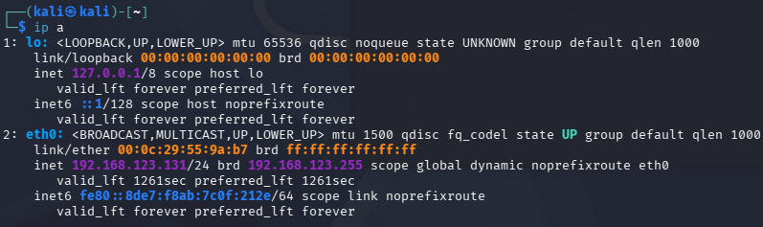
Task # 01 : Command ip a

Task # 01: Command ip a

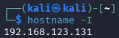

Task # 01: Command hostname -I

My Ip is 192.168.123.131.

• TASK # 02 •
Task # 02 : Gateway, Find Gateway.
Steps Followed:
- Open Kali Linux, then open terminal by using shortcut Ctrl + Alt + t.
- Type “ip route” to get your Gateway.
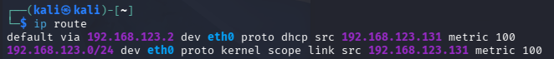

Task # 02: Command ip route

My Gateway is 192.168.123.2.

• TASK # 03 •
Task # 03 : DNS Server, Find DNS Server.
Steps Followed:
- Open Kali Linux, then open terminal by using shortcut Ctrl + Alt + t.
- Type “hostname -i” to get your DNS Server.
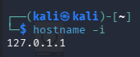

Task # 03: Command hostname -i

My DNS Server is 127.0.1.1.
• TASK # 04 •
Task # 04 : Active Interfaces, Find and List Active Interfaces.
Steps Followed:
- Open Kali Linux, then open terminal by using shortcut Ctrl + Alt + t.
- Type “ip a” to list your Active Interfaces.


Task # 04: Command ip a

My Active Interfaces are lo and eth0.

• TASK # 05 •
Task # 05 : Listening Ports, Find and List Listening Ports.
Steps Followed:
- Open Kali Linux, then open terminal by using shortcut Ctrl + Alt + t.
- Type “sudo netstat -tulnup” to list your Listening Ports.
Task # 05: Command sudo netstat -tulnup

As we can see, there are currently no Listening Ports. So, to force one, open another terminal and type “python3 -m http.sever 80” .
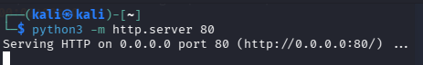
Task # 05: Command python3 -m http.sever 80

Then go back to the first terminal and type the same command “sudo netstat -tulnup”.
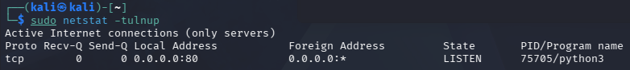

Task # 05: Command sudo netstat -tulnup

Now we have a listening port.

Assignment Conclusion:
In this assignment we ran some commands in Kali Linux to geta better understanding of networking fundamentals. This increased and polished my ability to use and learn more about cybersecurity.
• The End •

